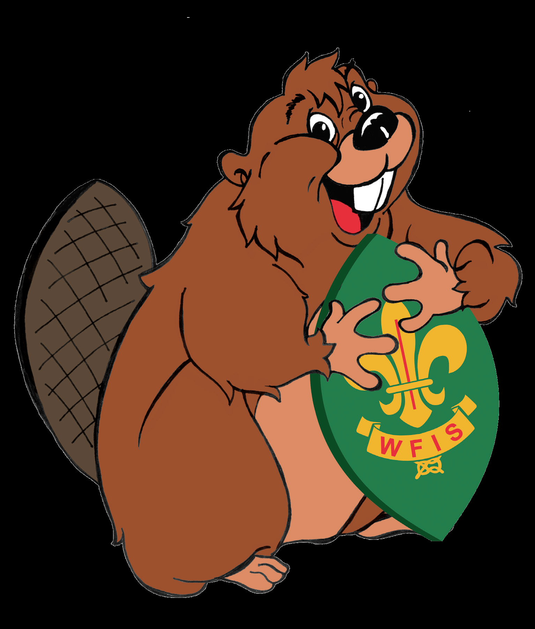

The Beaver Project – Sharing Fun

The Beaver Project – Sharing Fun is for Beavers all over Europe.

Through the sharing of fun Beavers from different areas or countries can share fun with other Beavers from WFIS - Europe.

Complete the registration form and send it to beavers@wfis-europe.org

Natacha Pierard is the Big Brown Beaver for the project. She is your contact if you have any questions about the project. You will get her contact details when you register.

Remember to order the Sharing Fun badges on the registration form.
The price for the badges is 1.50 Euro or £1.40 each.

You have to send the registration form before 30th of April 2019

It is very easy to join the sharing of fun, here is what you have to do:

- Send a photo of your Beavers looking happy.
- Make a picture of a Beaver to send to other Beavers, you could paint it, make it out of material stuck to card, anything you want.
- Sing a Beaver song and record it to send to other Beavers.
- Ask a leader to write a little about what you do at Beavers, so it can be read out to other Beavers.

From Big Brown Beaver you will get the name and address of a Beaver Colony to send your package to.

Registration Form

NAME OF GROUP:_______________________________________________________

ASSOCIATION:____________________________________________________________

COUNTRY: ______________________________________________________________

CONTACT PERSON:

NAME:___________________________________________________________________

ADDRESS:________________________________________________________________

_________________________________________________________________________

_________________________________________________________________________

TELEPHONE NUMBER:__________________________________________________

E-MAIL:_________________________________________________________________

HOW MANY BEAVERS?____________________________________________________

HOW MANY LEADERS?___________________________________________________

DO YOU WANT TO BUY THE SHARING FUN BADGE?

YES_______ NO:______

HOW MANY BADGES DO YOU WANT?_________________

Please remember each badge costs 1.50 Euro or £1.40 payable to
DE93513522270000010546
BIC:HELADEF1LAU
English Groups should send cheques directly to Julie Bryceson.

You have to send the registration form before the 30th April 2019

Please send this form to: beavers@wfis-europe.org

