Name of your organization:
Contact details: last name
first name
email-address
cell phone
In order to make your stay easy, pleasant and efficient, we request you for following further information:
Your intended way of travel:
 | date | train  no. | Railway  station | Arrival /  Departure time | pick-up/shuttle service required
ARRIVAL |  |  |  |  | ____ persons
DEPARTURE |  |  |  |  | ____ persons
Nearest major railway station: Giessen (trip can be continued to GRUENBERG or LICH which are closer to Laubach). We can organize pick-up to and from railway station located in GRUENBERG or LICH.

 | Surname | First  name | Handicapped | Sex |  | Preferred  nutrition |  |  | Food  intolerances
 |  |  |  | Male | Female | Non-Veg. | Veg. | Vegan | Lactose  intolerance | Gluten  intolerance | Others
1
2
3
4
5
6
7
8
9
10
11
12

We have decided to produce a special T-shirt for the Anniversary-Workshop. It can be purchased on order. If you would like to have one, please send us your binding order (quantity per size and at least one name of contact person) latest by 31. Juli 2026. Due to summer holiday season, the shirts must be ordered immediately to ensure they are available in time for the workshop. Only orders received by this date and with receipt of payment onto our account (see below again) by 31. Juli 2026 will be considered. It is not possible to order T-shirts at a later stage.

Size | XS | S | M | L
Quantity
Sub total | € | € | € | €
Size | XL | XXL | 3XL | 4XL
Quantity
 | € | € | € | €
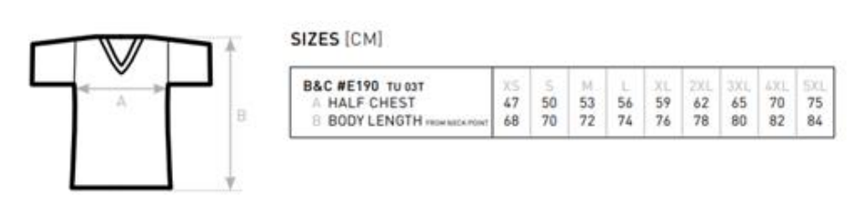
Pricing:
16,50 €/Shirt
(any size)

Please deposit the total fee for all of your ordered T-shirts NOT LATER than 31th of July 2026 at:

Account holder: Solmser Pfadfinderschaft
Bank: Sparkasse Laubach-Hungen
IBAN: DE33 5135 2227 0000 0088 13
SWIFT-code: HELADEF1LAU
Reference: WS 2026 plus name of your organization plus quantity of T-Shirts (total sum not for each size)

Due to the fact that we’ll have the celebration of 30yrs of WFIS, there is less time than usual for the Workshops, we’ll offer workshops for two- and four-hours duration.
Mode:
You can participate either …
up to two workshops of two hours (one in the morning, second in the afternoon)
or
one workshop of four hours
You can select several workshops but you need to indicate a priority (each with priorities 1,2,3). We’ll try to match your selection as much as possible!

2-hrs Workshops

- Scavenger Hunt (Geocaching) through Laubach
We have a walk through the village and old town of Laubach to answer exciting questions to get the coordinates of the treasury. We will have a look in the history and development of the town and our scouting activity.
Max. participants: 15

- Handmade Candles
In this workshop, participants will make their own candles from warm beeswax. Step by step, they will create a unique, handmade candle.
Max. participants: 10
- Stick Sword-Fighting
In this workshop, participants will learn the basics of stick sword-fighting: stance, footwork, and simple techniques. The focus is on coordination, reaction time, and safe handling.
Max. participants: 10
- DIY Bracelets
Create Your Own Unique Accessories
Max. participants: 15

- Astronomy
Learn a little bit from our stars and navigation with stars. Navigating the sky with your own rotating star chart
Max. participants: 10

- First Aid
Here, Scouts learn the most important steps of first aid — explained in an easy-to-understand way and put into practice right away. The workshop combines knowledge, practice, and responsibility.
Max. participants: 15

- Macramee
Here you can get creative, create keychains, mobile phone chains, bookmarks and much more.
Max. participants: 15

4-hrs Workshops

- Fabric Printing Workshop
Learn different methods for printing on fabric. Suitable for all ages, using inexpensive materials. Techniques include simple foam rubber stamps, lavender oil printing, and basic screen printing.
Max. participants: 10

- German Sourdough Bread Baking
Participants will learn about sourdough fermentation, dough handling, shaping, and baking.
Max. participants: 10
- (Viking) Camp Chair
Hands-on workshop focused on building a traditional Viking-style campchair using basic woodworking tools and techniques. Suitable for beginners.
Max. participants: 12

- Guitar Accords for Beginners
In this course, participants will learn basic chords, simple rhythms, and their first songs. Everything is explained step by step and put into practice right away.
Please inform us, whether you can bring along your own guitar or not (not mandatory).
Max. participants: 10

- Blacksmith your own item
This workshop introduces participants to the basics of blacksmithing — from heating the metal to the final finishing touches. Using a hammer and anvil, participants will create their own piece.
Max. participants: 10

- Pioneering
Rebuilding/Constructing of a hut at our campground
10 – 20 participants

- Basket making
In this beginner-friendly workshop, you will learn the basics of traditional basket weaving using natural materials (rattan cane). With step-by-step guidance, you’ll create your own small basket while discovering the techniques and craftsmanship behind this time-honoured skill.
Max. participants: 15

 | You can either participate up to two 2-hr-workshops OR one 4-hr-workshop  Choose any number of workshops.  If you pick several, assign priorities 1 = highest up to the number of workshops you selected = lowest. | 2-hrs-Workshops  (participate up to 2 workshops) |  |  |  |  |  |  |  |  | 4-hrs-Workshops  (partcipate only 1 workshop and put your priority)
 |  | Scavenger Hunt  (Geocaching) | Handmade Candles | Stick Sword-Fighting | DIY Bracelets | Astronomy | DIY bracelets | Astronomy | First Aid | Macramee | Fabric Printing | German Sourdough Bread Baking | Guitar Accords  (for Beginners) | Blacksmithing | Pioneering
 | Participants Name, First-Name
 | EXAMPLE (5 workshops selected) |  | 3 |  |  | 2 |  | 1 |  |  |  | 4 |  |  | 5
1
2
3
4
5
6
7
8
9
10
11
12

